Name: Abdurrahman Qureshi

Roll no: 210451

EXPERIMENT 12

Q.) WAP to implement COHEN SUTHERLAND CLIPPING ALGORITHM

CODE

#include<stdio.h>

closegraph();

#include<conio.h>

#include<graphics.h>

int xwmin=100,ywmin=100,xwmax=300,ywmax=300;

}

void encode()

{

float dy,dx,m;

int x1[3],y1[3],x2[3],y2[3],x,y;

int flag=0;

void encode();

void main()

{

int gd,gm;

clrscr();

detectgraph(&gd,&gm);

initgraph(&gd,&gm,"C:\\TC\\BGI");

for(int i=0;i<3;i++)

{

printf("Enter co-ordinates of line %d:",(i+1));

scanf("%d%d%d%d",&x1[i],&y1[i],&x2[i], &y2[i]);

line(x1[i],y1[i],x2[i],y2[i]);

}

rectangle(xwmin,ywmin,xwmax,ywmax);

getch();

cleardevice();

rectangle(xwmin,ywmin,xwmax,ywmax);

for(i=0;i<3;i++)

{

if(y1[i]>ywmax&&y2[i]>ywmax)

flag=1;

if(x1[i]>xwmax&&x2[i]>xwmax)

flag=1;

if(x<xwmin)

{

y=y+(xwmin-x)*m;

x=xwmin;

}

if(x>xwmax)

{

y=y+(ywmax-x)*m;

x=xwmax;

}

if(y<ywmin)

{

if(m!=0)

x=x+(ywmin-y)/m;

else

x=x+(ywmin-y);

y=ywmin;

}

if(y>ywmax)

{

if(m!=0)

x=x+(ywmax-y)*m;

else

x=x+(ywmax-y);

y=ywmax;

}

if(flag==0)

}

{

dy=y2[i]-y1[i];

dx=x2[i]-x1[i];

if(dx==0)

dx=1;

m=dy/dx;

x=x1[i];

y=y1[i];

encode();

moveto(x,y);

x=x2[i];

y=y2[i];

encode();

lineto(x,y);

}

}

getch();

OUTPUT:

BEFORE CLIPPING:
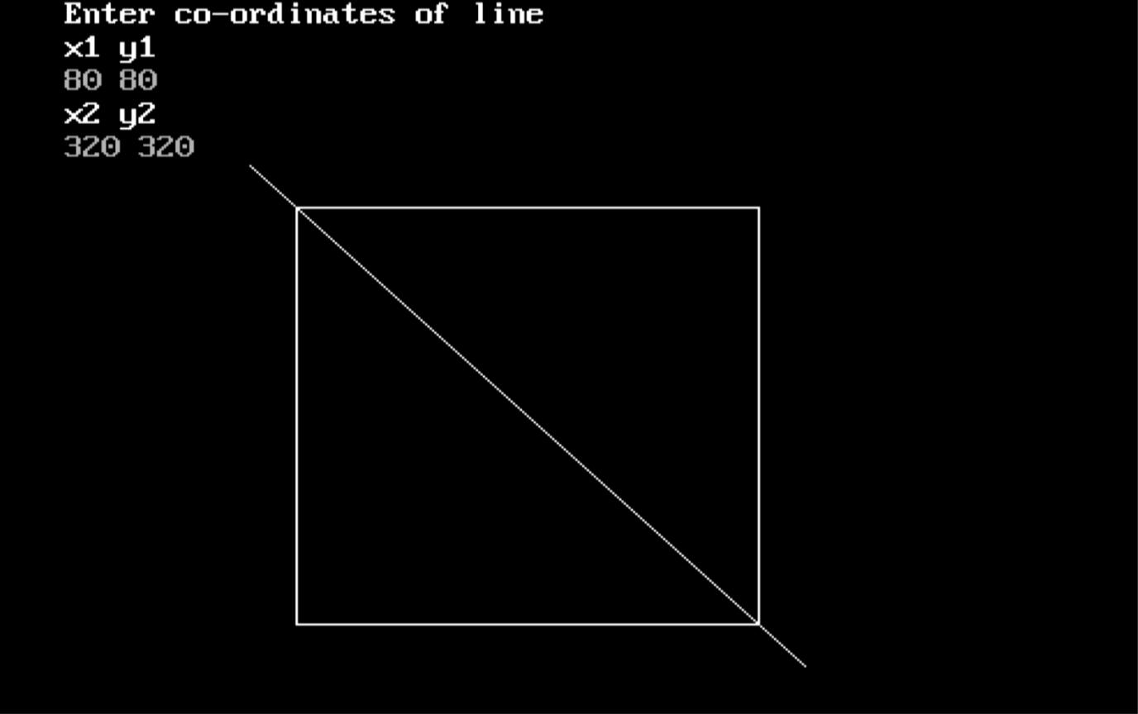

AFTER CLIPPING:
